Description:
ATM software system is a computerized banking system that allows authorized users to perform financial transactions without the need for direct interaction with bank staff. It provides a secure interface between the customer, the banking network, and the bank’s system to facilitate service like cash withdraws balance inquiry, fund transfer, and deposits.
UML Sequence Diagram:
This UML model describes how groups of objects interact among themselves through message passing to realize some behavior. A sequence diagram shows the interaction among objects as a two-dimensional chart. The chart is read from top to bottom.

UML Sequence Diagram for ATM software system:
Objects found in the system are:
- Customer,
- ATM,
- Bank.
In UML sequence diagram we will see their entire life span, how they connect with one another and, they interact with each other. In the diagram we will see vertically dotted line representing lifespan and the rectangles in the line indicate operative state of the object. Arrows are used for messages and specially dotted arrows used for reply, all the operations done in sequential manner from top to bottom.
Reference:
https://www.scribd.com/document/414154921/Project-Report-on-ATM-System-PDF
[N.B. The Sequential Diagram Given in Next Page]
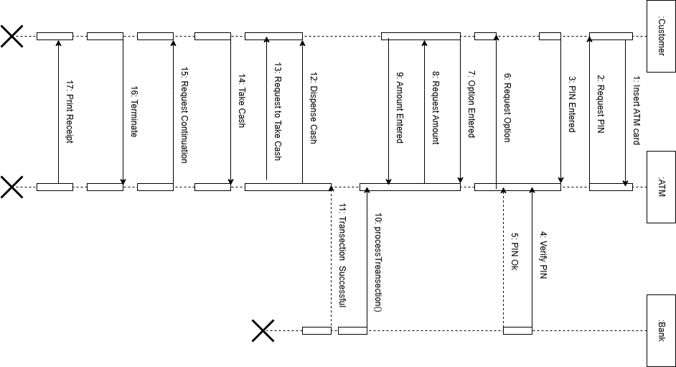
Fig: Sequential Diagram for ATM Software System.

